7.3.14 Editors - 3D View - Sidebar - Tool Tab - Grease Pencil - Weight Paint Mode
Grease Pencil - Weight Paint Mode 1
Weight Paint Mode - Brushes Panel 1
Brush browser 1
Weight Paint Mode - Brush Settings Panel 1
Radius 1
Strength 1
Weight 2
Use Falloff 2
Weight Paint Mode - Brush Settings Panel - Cursor Subpanel 2
Show Brush 2
Color 2

Grease Pencil - Weight Paint Mode

The Tools tab in Weight Paint Mode provides you the tools to do weight painting at a mesh. Skinned characters for example. Also grease pencil strokes can be skinned to a skeleton. In Weight Paint Mode you can weight paint your strokes.

Weight Paint Mode - Brushes Panel

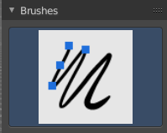
Brush browser
Pick a pencil, and see what pencil is active. There is just one pencil available for weightpainting.
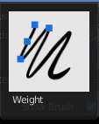

Weight Paint Mode - Brush Settings Panel

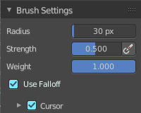
Radius
The radius of the brush.

Strength
The strength of the brush.

Weight
The target weight. Everything below gets added towards this value. Everything above gets subtracted from this value. Usually you work with the maximum value of 1.

Use Falloff
Use Falloff for the brush.

Weight Paint Mode - Brush Settings Panel - Cursor Subpanel
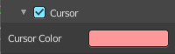

Show Brush
Show the brush icon when painting.

Color
The brush icon color.

